M/s. Fidelity Assurance & Reinsurance Co. S.A.L. - M/s. El Mazraa Company for Traditional Food– Fire Damage

Our reference: ULA 250615 - 1v2
Insured: M/s. El Mazraa Company for Traditional Food
Insurer: M/s. Fidelity Assurance and Reinsurance Co. S.A.L.
04 November 2025

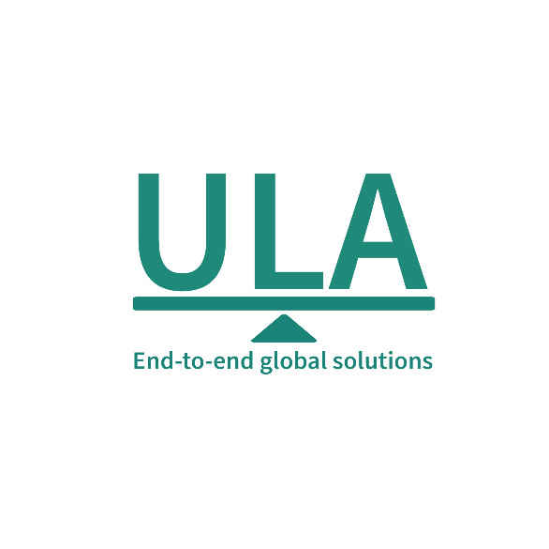
[Insert here client logo]
It’s about time you receive the quality of service and expertise your firm deserves.
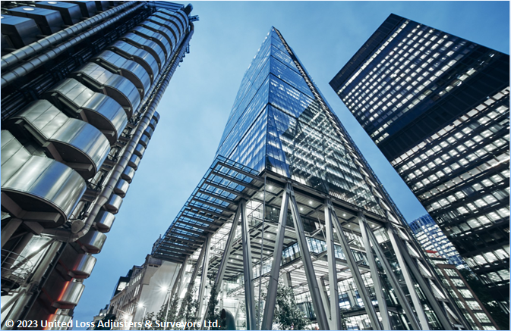

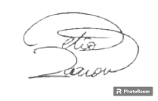
Document Control Page
written by: | Reviewed by: |  | Approved by:
Jean Claude Chahine  Fayez Dghaily | Annie Abdel Massih |  | Petro Zaarour
Designation: | Designation: |  | Designation:
Liability Claims Manager  Technical Specialist | Claims Director |  | Chartered Engineer, Loss & Average Adjuster
Signature (Approver)
This survey and its preliminary report were completed without prejudice to all rights of parties concerned.
Date of visits
First visit: 7 June 2025 |  | Last visit: 9 October 2025
Date of approval
04 November 2025

Version history | Date of issue | Reason for Revision
1 | 25 August 2025 | Preliminary Issue - Pending receipt of all Invoices / Quotations
2 | 04 November 2025 | Final Issue

The contents of this report are for the confidential information of the client.

Report Summary
At the request of M/s. Fidelity Assurance & Reinsurance Co. S.A.L (the Insurer), United Loss Adjusters and Surveyors (ULA) was appointed to attend the premises of the Insured, Messrs. El Mazraa Company for Traditional Food, operating a restaurant located in Beirut, Lebanon. This appointment followed a notification that the insured premises had been affected by a fire originating in their kitchen. In response, ULA conducted an initial site visit on 7 June 2025, followed by several subsequent visits.
The purpose of these visits was to carry out a joint survey to assess the extent of loss and damage sustained by the Insured premises, to provide appropriate recommendations for any identified loss, and to gather sufficient information to support the validation of the claim. This loss particulars are shown in Table 1.
Insurer | M/s. Fidelity Assurance and Reinsurance Company SAL
Insured | M/s. El Mazraa Company for Traditional Food
Basis of Settlement | Depreciation basis
Cause of damage | The fire was reportedly caused by a gas (Butane) leak from the kitchen’s installed gas piping system
Incident & Discovery | 7 June 2025
Initial survey date | 7 June 2025 and several subsequent dates
Present during the surveys | Mr. Nabil Jaber -The Insured  Mr. Hovig Kalandjian & Mr. Feyez Dghaily - Surveyors to ULA
Claim presented to date | Insured’s Initial Claim: USD 67,446.00  Insured’s Final Claim: USD 81,855.40
Incident Overview: On 7 June 2025 at approximately 10:00 AM, a fire broke out in the kitchen of Al Mahata Restaurant, located in the Mazraa area of Beirut. The fire was caused by a gas leak in the manifold of the kitchen’s gas piping system, which ignited during routine morning preparations. One employee sustained burns to his hands while attempting to operate the grill.
Emergency Response: Despite the staff’s immediate use of six dry powder fire extinguishers (3 x 12 kg and 3 x 6 kg, valid until 08.08.2025), they were unable to control the fire. The Civil Defense was called and arrived around 10:15 AM, successfully extinguishing the blaze within 30 minutes, preventing further spread beyond the kitchen area.
Business Impact: The fire rendered the only kitchen inoperative, forcing the restaurant to close temporarily. Partial reopening with limited equipment occurred on 14 July 2025, as a mitigation measure to reduce further financial losses.
Damage Assessment: ULA confirmed significant fire, smoke, and heat damage to the kitchen infrastructure, electrical components, and equipment such as grills, fryers, and refrigerators. Debris and destruction were widespread across the kitchen and adjoining areas.
Cause of Damage: Investigations by both ULA and the Lebanese Civil Defense concluded that the fire was caused by a gas leak in the manifold system. This finding is consistent with physical evidence and the Insured’s formal written declaration.
Final Visit: A follow-up / final inspection conducted on 20 October 2025 confirmed that the Insured completed all repairs and implemented the recommended preventive measures. However, the invoices submitted (valued at USD 81,855.40) include costs for both the repairs covered and additional upgrades made throughout the restaurant.
Conclusions:
- The adjusted claim amount USD 41,003.87 (Table 2 refers), is considered fair & reasonable;
- The claim should be recoverable under the policy since the damage resulted from a 'fire’, an insured peril;
- The Insured had insurable interest at the time of damage and Insurers were on risk;
- The Insured complied with the policy material conditions and warranties, which should not bar them from recovering on the subject policy;
We confirm to have sighted the originals of all documents submitted in support of a claim of this nature.
Contents
1. Appointment of ULA by Insurers 5
2. Description of business 7
3. Description of premises and loss history 7
4. Discovery time and date 7
5. Spread and stop 8
6. Nature and extent of loss and damage 8
6.1. Fire investigator insight into the cause of fire (engaged by ULA) 9
6.2. Summary of the incident 9
6.3. Fire protection and prevention measures 9
7. Final visit 9
8. Final claim on the policy & Adjustment 10
9. Relevant basis of cover, warranties and conditions 12
10. Warranties Commentary 14
11. Adequacy of sums insured 14
12. Conclusion 14

Appointment of ULA by Insurers
At the request of M/s. Fidelity Assurance & Reinsurance Co. S.A.L (the Insurer), United Loss Adjusters and Surveyors (ULA) was appointed to attend the premises of the Insured, Messrs. El Mazraa Company for Traditional Food, operating a restaurant located in Beirut, Lebanon. This appointment followed a notification that the insured premises had been affected by a fire originating in their kitchen. In response, ULA conducted an initial site visit on 7 June 2025, followed by several subsequent visits.
The purpose of these visits was to carry out a joint survey to assess the extent of loss and damage sustained by the insured premises, to provide appropriate recommendations for any identified loss, and to gather sufficient information to support the validation of the claim. This loss particulars are shown in Table 1.
As a result of the incident, the restaurant’s only kitchen was rendered inoperative, causing business interruption from 7 June 2025 until 14 July 2025. The Insured managed to partially reopen using minimal equipment in an effort to mitigate further losses. Representative survey photographs are further included in ‎0.
Table 1 - Loss particulars
Insurer | M/s. Fidelity Assurance and Reinsurance Company SAL
Insured | M/s. El Mazraa Company for Traditional Food
Basis of Settlement | Depreciation basis
Insurance Policy No. | FIR-5126651-04-00  Inception Period: 16.03.2025 – Expiry Date: 16.03.2026  Contents are covered for a sum of USD 110,000.00:  - USD 20,000.00 – Kitchen appliances, electrical installations  - USD 15,000.00 – Food and Beverage Stock  - USD 5,000.00 – Furniture  - USD 70,000.00 – Decoration, fixtures & fittings  Clearance of Debris is covered for a sum of USD 5,000.00  Architect and Surveyor’s Fees covered for a sum of USD 1,500.00
Special Clauses | B3-Deterioration of stock following Fire:  Notwithstanding anything to the contrary contained in the present policy, it is hereby declared and agreed to include in the Cover Deterioration of Stock in cold storage following a covered Fire up to the Sum indicated hereabove. This Section is however, subject to an Excess deductible of US$ 200 applicable on each & every Loss.  B12 - Liability Towards Landlords:  The Company shall indemnify the Insured for his financial liability in respect of all Physical Damage caused to the building occupied by him and occasioned by a covered accident which the Insured in his capacity as Tenant or Occupant may have to bear in accordance with the legislation in force, and more precisely the stipulations of Articles 566 & 567 of the Law of Obligations & Contracts.
Special Conditions | A4 - Firefighting equipment:  Warranted that Fire Fighting Extinguishers should be fixed on walls at different places easily accessible within the insured premises, that they are maintained in operational order in accordance with the suppliers' recommendations and operational 24h a day. Any failure of operation duly noted by the Company’s Loss Adjuster at time of Loss will nullify any Fire Claim.  A6 - Extraction & Cooking Equipment:  It is warranted that where present, all cooking fume extraction canopies ductwork and the like be washed/wiped daily and cleaned at least once a year by independent contractors and that filter traps and other grease removal devices therein be thoroughly cleaned at least once a month.  A7 - Deep Fat Frying Warranty It is warranted that:  (a) A thermostat is fitted to the frying range where the operating temperature does not exceed 205°C or the suppliers recommended temperature.  (b) A high temperature limit control of a non-self-resetting type is fitted to shut off the heat source if the temperature of the fat or oil exceeds 230°C.  (c) The extraction system must vent directly to the outside of the premises.  (d) None of the range or associated equipment including ducting and hoods shall be within 150 mm of any combustible materials,  (e) All grease traps, filters and other removable devices must be cleaned every week.  (f) The grease extract ducting shall be cleaned every 12 months.  (g) The entire range and associated equipment shall be serviced by the manufacturer/installer or an independent qualified contractor every 12 months.  (h) The frying range shall be attended at all times whilst the range is turned on.  (i) All waste/scraps shall be kept in metal bins and removed at least once a week from the premises.  (j) One 10 kg extinguisher must be installed in the vicinity of the range.
Insured premises | Restaurant Al Mahata, Mazraa, Beirut – Plot no. 3613
Cause of damage | The fire was reportedly caused by a gas leak from the kitchen’s installed gas piping system
Incident & Discovery | 7 June 2025
Initial survey date | 7 June 2025 and several subsequent dates.
Present at Survey | Mr. Nabil Jaber -The Insured  Mr. Hovig Kalandjian & Mr. Feyez Dghaily - Surveyors to ULA
Claim presented to date | Insured’s Initial Claim: USD 67,446.00  Insured’s Final Claim: USD 81,855.40
Policy Governing Law & Jurisdictions | Lebanon (Governing law and jurisdiction)

Description of business
The policy schedule indicates that Insurers are providing coverage for the insured property, which is described as a ‘Full-Service Restaurant’ situated on the Ground Floor of the Saab Building, main Street, Mazraa, Beirut. plot no.3613. The said Building is composed of one basement, a ground floor and six upper floors, built entirely of stone and /or reinforced concrete & roofed with the same.
Based on the inspection of the premises insured, we were able to confirm that this description accurately reflects the current layout and usage of the property.

Description of premises and loss history
The Insured has been leasing the restaurant premises located at Mazraa, Beirut, Plot No. 3613, with a total area of 250 m², since July 2004. According to the Insured’s verbal declaration, the lease has been automatically renewed on an annual basis since inception.
Upon review of the lease agreement (copy enclosed – Arabic version), it is noted that there are no specific provisions placing insurance obligations or liability for damage on the premises owner. Instead, such responsibilities appear to fall on the tenant.
The Insured confirmed that they voluntarily elected to obtain insurance coverage under the subject policy. With respect to the loss history, the Insured verbally confirmed that no prior incidents or claims have occurred at the premises since they commenced leasing the property in July 2004. Insurers are recommended to confirm the same.
The insured premises comprise a restaurant seating area, a cashier counter, a barbecue and shawarma stand, grill, deep fryer, oven, refrigerators, a refrigerated room, shelving units for food storage, and a designated food preparation area.

Discovery time and date
On the morning of 7 June 2025, at approximately 10:00 AM, a gas (Butane) leak occurred within the manifold of the kitchen’s gas piping system. The leaking gas ignited, resulting in a flame that rapidly spread to the adjacent gas cylinders. This led to a significant blaze that caused extensive damage to the kitchen and the majority of its equipment.
According to the Insured’s formal declaration (copy enclosed - Arabic Version):
"I, Nabil Jaber, owner and manager of Al Mazraa Company for Traditional Foods (Shawarma Station) would like to inform you that the fire that broke out in the restaurant on 07/06/2025 started while the workers were carrying out their morning preparations. During this time, they were suddenly surprised by a fire erupting from the gas stove. They attempted to extinguish the flames using the fire extinguishers available in the restaurant, but the intensity of the fire made it impossible to intervene. One of the workers burnt his hands severely and could hardly get close to the source. As a result, employees fled the premises, and the fire department was immediately contacted. The fire brigade succeeded in extinguishing the fire. However, the fire had already consumed the entire shawarma station, grills, and kitchen area. It also caused extensive damage across the rest of the restaurant."
This statement is consistent with the physical evidence observed during the survey and supports the conclusion that the loss or damage resulted from a fire caused by a gas leak in the kitchen area.

Spread and stop
The insured employees attempted to extinguish the fire using the available fire extinguishers in the restaurant but failed due to its intensity. The Civil Defense/fire brigade personnel later arrived at the scene and successfully put it out. No damage to third parties, including neighbors, was sustained.

Nature and extent of loss and damage
Following ULA’s initial inspection on 07 June 2025, conducted in the presence of the Insured, Mr. Nabil Jaber, the following observations were made:
- Severe Fire and Smoke Damage: The entire kitchen area was heavily affected by soot and ash, indicating extensive fire and smoke exposure. Surfaces, including counters, stoves, and walls, were heavily blackened and coated with residue.
- Destruction of Equipment and Appliances: The fryer, grill, gas cooker, and various kitchen appliances and utensils were either deformed or destroyed due to intense heat. Cooking items such as pans, pots, and metal shelving displayed severe charring and warping.
- Structural and Mechanical Damage: Significant thermal damage was noted on walls, ceilings, ventilation ducts, and electrical fixtures. Several components appeared melted, warped, or coated in thick soot. Residual smoke damage extended beyond the kitchen into other sections of the restaurant.
- Debris and Fire Remnants: The kitchen floors and countertops were littered with debris, including partially melted tools, broken fixtures, and other unidentifiable fire-damaged materials.
- Preservation of the Scene: The Insured was formally advised to take all reasonable steps to minimize further losses and to preserve the fire’s point of origin until ULA’s investigation and inspections were concluded.
- Follow-Up Visits: In addition to the initial attendance on 07 June 2025, multiple subsequent site visits were conducted to support the Insured and to guide the documentation and validation process related to the submitted claim.
The condition of the site was consistent with fire damage that caused substantial damage to both the kitchen infrastructure and its contents. Representative photographs of the damage are included in Appendix A.
Figure 1 - Fire damage across the kitchen area
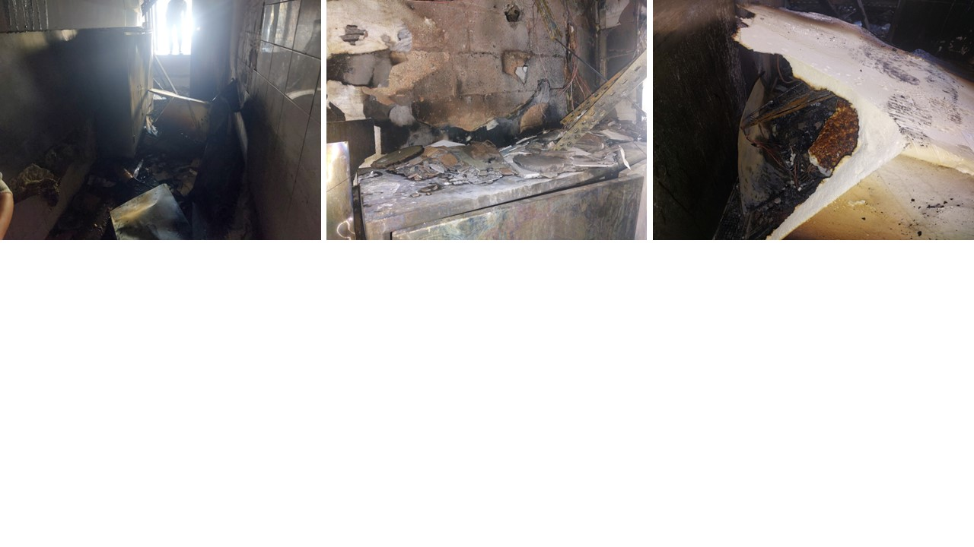

Fire investigator insight into the cause of fire (engaged by ULA)
At the time of loss, the fire was naturally investigated by the Lebanese Civil Defense (government investigation body responsible for fire and emergency response), whose report identified the origin of the fire as the leakage of gas in the manifold of gas pipes (copy enclosed).
On completion of the investigations, both ULA Surveyors, their engaged fire expert, and the Civil Defense concluded an identical cause of the fire, a leakage in the manifold of the gas pipes.

Summary of the incident
On June 7 at approximately 10:00 AM, a fire broke out at Al Mahata Restaurant, located in the Mazraa area of Beirut. The incident caused significant damage to the kitchen and led to a disruption in the restaurant’s business operations. The fire started while an employee was preparing the kitchen for the day and attempting to turn on the grill. Unknown to him, there was a gas leak, and as he ignited the grill, a fire suddenly erupted. The employee was caught by surprise and sustained burns to his hands as a result of the sudden blaze.
Despite his injuries, the employee quickly attempted to contain the fire by grabbing the nearest fire extinguisher. Other staff members immediately joined in, using several extinguishers available on the premises to try and put out the flames. However, their combined efforts were not enough to control the fire. Mr. Nabil Jaber, the owner and manager of the restaurant, was informed of the incident and promptly contacted the Civil Defence.
The Civil Defence arrived at the scene around 10:15 AM and managed to extinguish the fire within approximately 30 minutes. Their swift response prevented the fire from spreading beyond the kitchen to other areas of the restaurant. While no further injuries were reported, the fire caused considerable property damage and forced a temporary halt to the restaurant’s operations.

Fire protection and prevention measures
Fire protection and prevention measures were in place at Al Mahata Restaurant at the time of the incident. A total of six dry powder fire extinguishers had been strategically installed throughout the premises and were readily accessible to staff. These included three extinguishers of 12 kg capacity and three of 6 kg capacity, all with a valid expiry date of 08.08.2025. When the fire broke out, employees promptly utilised these extinguishers in an attempt to control the blaze prior to the arrival of the Civil Defense. Despite their efforts, the fire could not be fully contained, but the immediate use of the extinguishers helped delay its spread and minimize further damage.

Final visit
The insured informed ULA that the repairs were completed and the remaining invoices were collected. A follow-up visit was conducted on 20 October 2025 to assess the repairs, validate them and ensure similar events would be prevented in the future.
Following ULA’s final visit, it was evident that the Insured not only repaired the damage sustained but also undertook upgrades/betterments to the entire restaurant. The invoices presented referred not only to the repair of the damaged areas but also included costs associated with general improvements and enhancements made throughout the premises (Claims and Adjustment Discussed in Table 2).

Final claim on the policy & Adjustment
To date, the claim presented on the policy by the Insured pertaining to the repairs and replacements by several suppliers can be summarised as follows:
- Electrical Equipment
- Kitchen Equipment
- Food Stock
- Others such as WIFI, routers, telephone controllers, surveillance cameras and peripherals.
- Labor
- Construction works (tiling, painting …)
It is worth noting that the policy basis of cover does not incorporate a Payment on Account (PoA) facility.
The final claim presented amounted to a final claim of USD 81,855.40, having received all final invoices from the Insured. It should be noted that these figures are unadjusted and do not consider policy coverage at this point.
To date, no claim for business interruption or bodily injury has been put forward by the Insured. All items outlined in Table 2 were beyond salvage sale and do not retain residual values.
On the basis of evidence presented and in accordance with the basis of settlement, further validated by the undersigned, the following depreciations were adopted:
- The replaced electrical items were subjected to a 20% depreciation, as renewed approximately one year ago.
- The non-electrical equipment and installations were subject to a 30% depreciation to account for their age and wear.
Table 2 – Final claim & adjustment
Document No. | Description | Claimed Amount | Adjusted Amount & ULA Comments
Receipt dated 20/07/2025 issued by Mr. Basel Jafan | Tiling labor | USD 14,000.00 | The Insured performed new tiling in the entire restaurant.  The affected area was circa 162.08 m² x market price for tiling labor is USD 12.00 / m² = USD 1,944.96
Receipt No. 11 Issued by Mr. Abdul Rahman Al Nabhan | Painting works | USD 3,000.00 | The entire restaurant was affected by soot – fair & reasonable  USD 3,000.00
Receipt Voucher No 148104 Dated 11/06/2025 | Labor (not specified) | USD 3,000.00 | Not clear – not covered
Quotation No 25Q-0771 issued by M/s Emporio Ceramico | Miraju Graphite 12 mm Ceramic tiles 110.4 m2 + transportation | USD 1,821.60  + USD 40.00 | Kitchen tiles + transportation covered  USD 1,861.60
 | 8 slabs of black Marquina tile | USD 1,555.20 | New betterment décor - Not covered
Invoice order No 2025153 issued by M/s Abdul Hadi Dimashkiek. EST | Hardware | USD 120.86 | Covered - fair & reasonable  USD 120.86
Invoice order No 2025140 issued by M/s Abdul Hadi Dimashkiek. EST | Hardware | USD 1,138.00 | Covered - fair & reasonable  USD 1,138.00
Invoice order No. 2025139 issued by M/s Abdul Hadi Dimashkiek. EST | Hardware | USD 682.88 | Covered - fair & reasonable  USD 682.88
Invoice order No. 2025131 issued by M/s Abdul Hadi Dimashkiek. EST | Hardware | USD 1,170.20 | Covered - fair & reasonable  USD 1,170.20
Invoice order No. 2025126 issued by M/s Abdul Hadi Dimashkiek. EST | Hardware | USD 202.65 | Covered - fair & reasonable  USD 202.65
Sales invoice No. 001-2025 – Si-196  Issued by M/s. Spicy Food | Kitchen food inventory (Spices) | USD 330.00 | Covered - Stock  USD 330.00
Sales invoice No. 3598 Issued by M/s. MAJCO S.A.L | Lighting equipment | USD 620.17 | 20% depreciation – Electrical  USD 520.13
Invoice No. SA2-8443 Issued by M/s. AICO | Sanitary equipment | USD 806.00 | Covered - fair & reasonable  USD 806.00
Invoice No. SA2-8444 Issued by M/s. AICO | Sanitary equipment | USD 360.00 | Covered - fair & reasonable  USD 360.00
Invoice No. 91 Issued by M/s. Mind Technology | Electrical & Sound system equipment | USD 1,148.00 | 20% depreciation – Electrical  USD 918.40
Invoice No. 93 Issued by M/s. Mind Technology | Lighting, network & electrical equipment | USD 3,654.00 | 20% depreciation – Electrical  USD 2,923.20
Invoice No. 90 Issued by M/s. Mind Technology | Lighting & electrical equipment | USD 737.40 | 20% depreciation – Electrical  USD 589.92
Invoice No. 5022 Issued by M/s. Tamer Al Daher | Tools & Hardware | USD 153.60 | Covered - fair & reasonable  USD 153.60
Invoice No. 5009 Issued by M/s. Tamer Al Daher | Tools & Hardware | USD 568.30 | Covered - fair & reasonable  USD 568.30
Invoice No. 2026 Issued by M/s. Tamer Al Daher | Tools & Hardware | USD 11.00 | Covered - fair & reasonable  USD 11.00
Invoice No. 2032 Issued By M/s. Tamer Daher | Tools & Hardware | USD 334.95 | Covered - fair & reasonable  USD 334.95
Invoice No. 5024 Issued by M/s. Tamer Al Daher | Tools & Hardware | USD 325.60 | Covered - fair & reasonable  USD 325.60
Invoice No. 2025 Issued by M/s. Tamer Al Daher | Tools & Hardware | USD 235.00 | Covered - fair & reasonable  USD 235.00
Invoice No. 2029 Issued by M/s. Tamer Al Daher | Tools & Hardware | USD 128.25 | Covered - fair & reasonable  USD 128.25
Invoice No. 0242 Issued by M/s. Azab General Trading | Stainless steel kitchen equipment | USD 310.00 | 30% depreciation – Non-Electrical USD 217.00
Invoice No. 0240 Issued by M/s. Azab General Trading | Stainless steel kitchen equipment (fridge, grill …) | USD 14,625.00 | 20% depreciation – Electrical USD 11,700.00
Invoice No. 0241 Issued by M/s. Azab General Trading | Stainless steel kitchen equipment | USD 5,345.00 | 30% depreciation – Non-Electrical USD 3,741.50
Invoice No. 3588 Issued by M/s. RISLANCO | Repair & replacement for kitchen equipment | USD 2,485.00 | Covered - fair & reasonable  USD 2,485.00
Invoice No. 3587 Issued by M/s. RISLANCO | AC 9 units (ceiling mounted) | USD 13,600.00 | The installed AC units are an upgrade from what was installed (General AC split units), 4 affected x USD 650.00 – market price = USD 2,600.00  20% depreciation – Electrical USD 2,080.00
Invoice No. 3586 Issued by M/s. RISLANCO | AC copper installations | USD 6,902.00 | Fair & reasonable for the affected 4 AC units = USD 500.00
Invoice No. 0065 Issued by M/s Icon Lighting S.A.R. L | Aluminium profile + lighting equipment | USD 1,632.90 | Covered - fair & reasonable  USD 1,632.90  30% depreciation – Non-Electrical USD 1,143.03
Invoice No. 1368665 Issued by M/s. SARAH | Fire Extinguishers refill  4x12kg, 1x6 kg, 1x5kg, 1 Co2 | USD 140.00 | Covered - fair & reasonable  USD 140.00
Invoice dated 14/06/2025 Issued by M/s. Salameh Ceramica S.A.L | Light grey 30 X 30 ceramic tiles 51.68 m2 | USD 671.84 | Covered - fair & reasonable  Kitchen tiles  USD 671.84
Total Claim & Adjusted Amounts | USD 81,855.40 |  | USD 41,003.87
Say U.S. Dollars Forty-One Thousand Three & 87/100 Only

Relevant basis of cover, warranties and conditions
The relevant basis of cover, warranties and conditions pertaining to this fire incident are summarised as follows:
- Contents Insured for a sum of USD 110,000.00:
- USD 20,000.00 – Kitchen appliances, hi-fi stereo, electrical installation and other items related to the insured’s business.
- USD 15,000.00 – Stock of foodstuff, beverages, and/or all other similar items necessary for the insured’s business.
- USD 5,000.00 – Furniture.
- USD 70,000.00 – Decoration, fixtures, and fittings.
- Clearance of Debris covered for a sum of USD 5,000.00.
- Architect and Surveyor’s Fees covered for a sum of USD 1,500.00.
Special Conditions:
- A4 - Firefighting equipment: Warranted that Fire Fighting Extinguishers should be fixed on walls at different places easily accessible within the insured premises, that they are maintained in operational order in accordance with the suppliers' recommendations and operational 24h a day. Any failure of operation duly noted by the Company’s Loss Adjuster at time of Loss will nullify any Fire Claim.
- A6 - Extraction & Cooking Equipment: It is warranted that where present, all cooking fume extraction canopies ductwork and the like be washed/wiped daily and cleaned at least once a year by independent contractors and that filter traps and other grease removal devices therein be thoroughly cleaned at least once a month.
- A7 - Deep Fat Frying Warranty: It is warranted that:
(a) A thermostat is fitted to the frying range where the operating temperature does not exceed 205°C or the suppliers recommended temperature.
(b) A high temperature limit control of a non-self-resetting type is fitted to shut off the heat source if the temperature of the fat or oil exceeds 230°C.
(c) The extraction system must vent directly to the outside of the premises.
(d) None of the range or associated equipment including ducting and hoods shall be within 150 mm of any combustible materials.
(e) All grease traps, filters and other removable devices must be cleaned every week.
(f) The grease extract ducting shall be cleaned every 12 months.
(g) The entire range and associated equipment shall be serviced by the manufacturer/installer or an independent qualified contractor every 12 months.
(h) The frying range shall be attended at all times whilst the range is turned on.
(i) All waste/scraps shall be kept in metal bins and removed at least once a week from the premises.
(j) One 10 kg extinguisher must be installed in the vicinity of the range.

Special Clauses:
- B12 - Liability Towards Landlords the Company: Shall indemnify the Insured for his financial liability in respect of all Physical Damage caused to the building occupied by him and occasioned by a covered accident which the Insured in his capacity as Tenant or Occupant may have to bear in accordance with the legislation in force, and more precisely the stipulations of Articles 566 & 567 of the Law of Obligations & Contracts.
- B3-Deterioration of stock following Fire: Notwithstanding anything to the contrary contained in the present policy, it is hereby declared and agreed to include in the Cover Deterioration of Stock in cold storage following a covered Fire up to the Sum indicated hereabove. This Section is, however, subject to an Excess deductible of US$200 applicable to each & every Loss.
No stock was claimed for by the Insured.

Warranties Commentary
It was confirmed that all extinguishers on-site were within their validity period, with an expiry date of 08 August 2025. This confirmation indicates that the extinguishers complied with the applicable safety standards and, in our view, fulfilled the conditions outlined in the relevant warranty. The remaining claim material warranties (paragraph 9 refers) were also reviewed and confirmed to have been complied with.
We are of the view that the claim material warranties requirements were complied with at the time of the incident and Insurers are recommended to advise their position accordingly.

Adequacy of sums insured
The policy provides a basis of cover for the following relevant items and their sum insured as follows:
- USD 20,000 – Kitchen appliances, hi-fi stereo, electrical installation and other items related to the insured’s business.
- USD 15,000.00 - Stock of foodstuff, beverages and/or all other similar items necessary for the Insured’s business.
- USD 5,000.00 – Furniture.
- USD 70,000.00 - Decoration, fixtures and fittings.
The value of the items matches the insured amounts, indicating that the coverage is appropriate. Therefore, we are of the view that there is no evidence of underinsurance, as the sums insured align with the actual value of the assets.

Conclusion
In our opinion,
- The adjusted claim amount USD 41,003.87 is considered fair & reasonable;
- The claim should be recoverable under the policy since the damage resulted from a 'fire’, an insured peril;
- The Insured had insurable interest at the time of damage and Insurers were on risk;
- The Insured complied with the policy material conditions and warranties, which should not bar them from recovering on the subject policy;
- We confirm to have sighted the originals of all documents submitted in support of a claim of this nature.
Claim relevant enclosed documents as made available by the Insured:
- Insurance policy No.: FIR-5126651-04-00
- Registry of Commerce license
- Rental Agreement & Management Contract
- Civil Defence Report
- Insured’s Declaration
- Invoices

            - Survey representative photographs from the different dates of attendance – More photographs are available on request
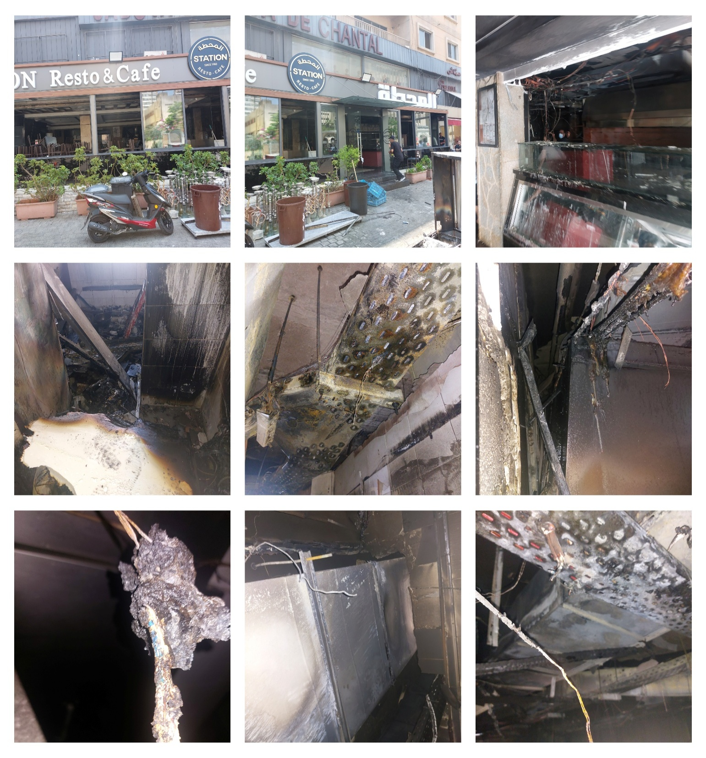

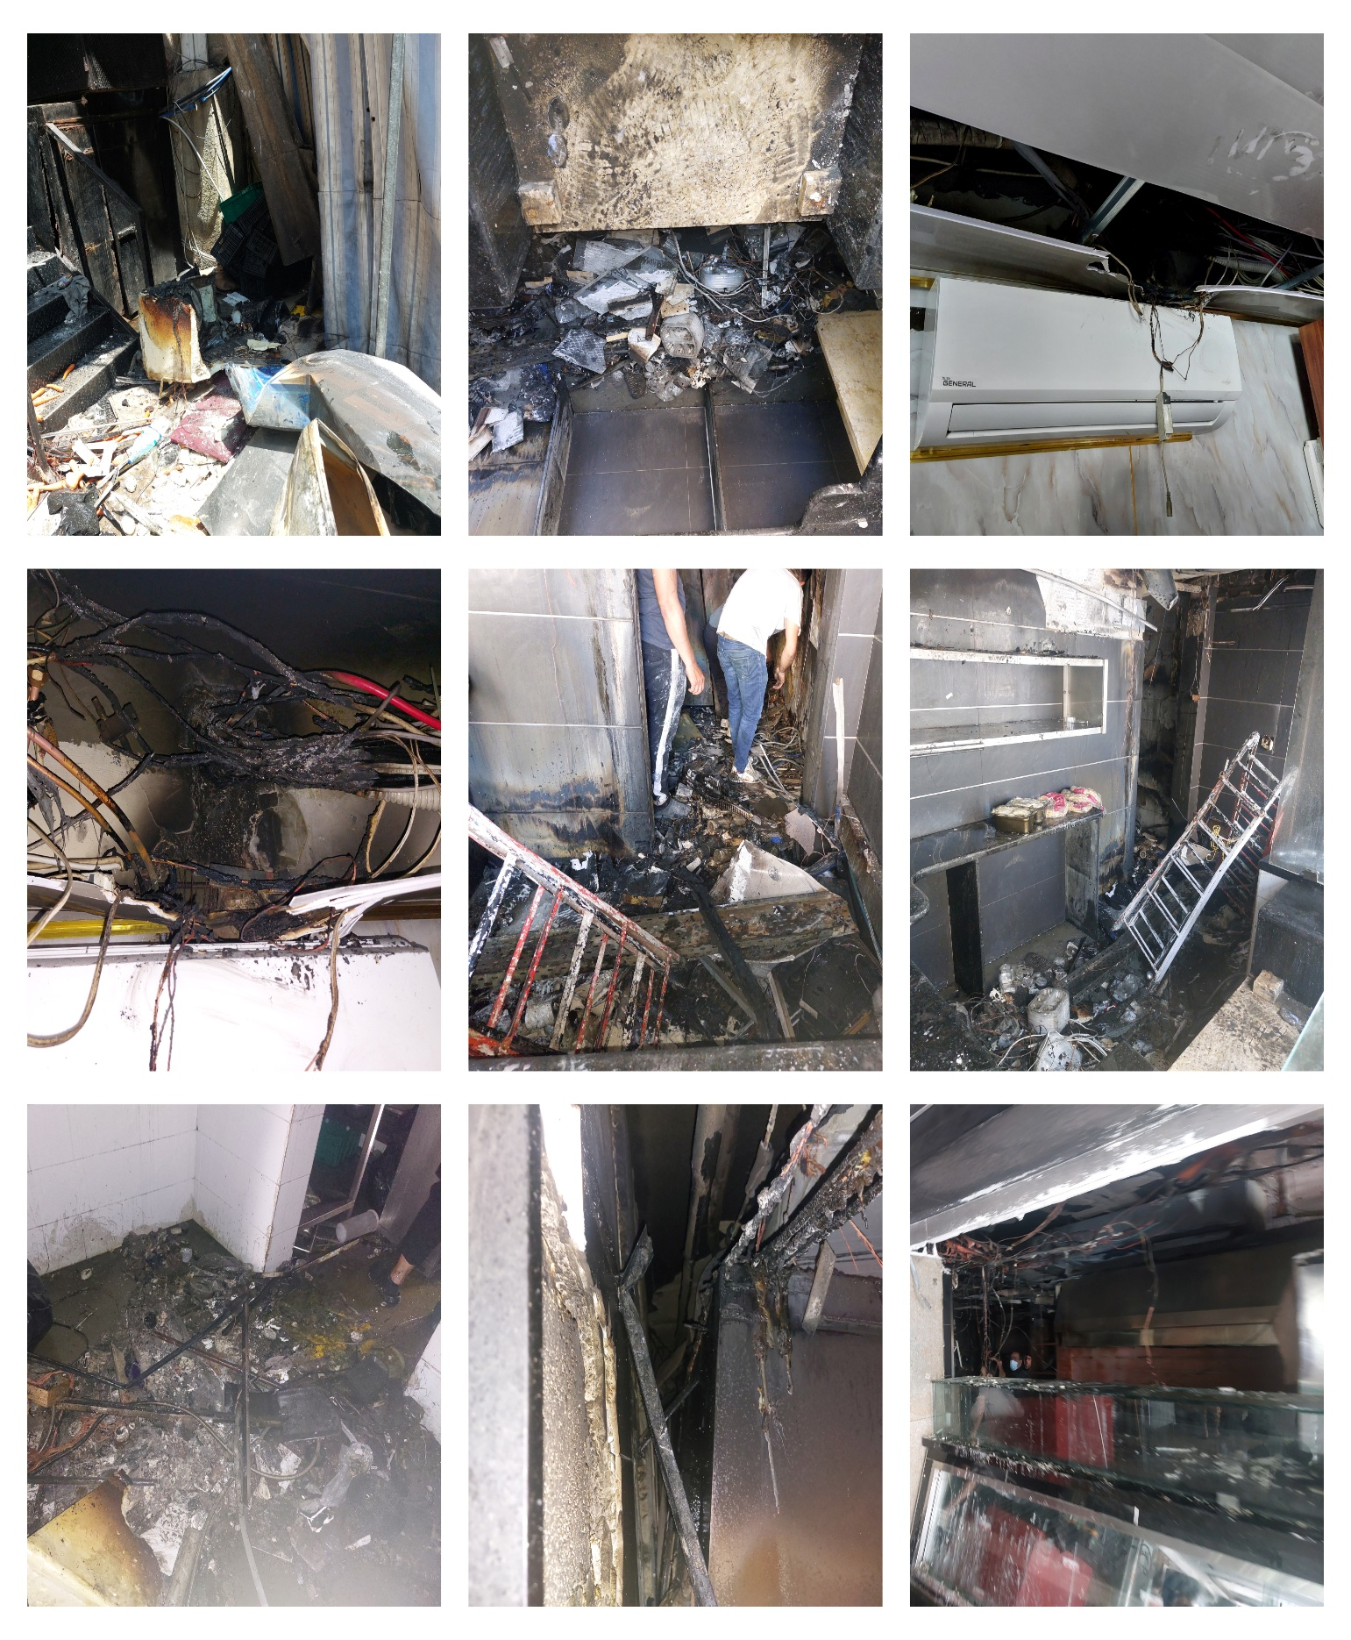

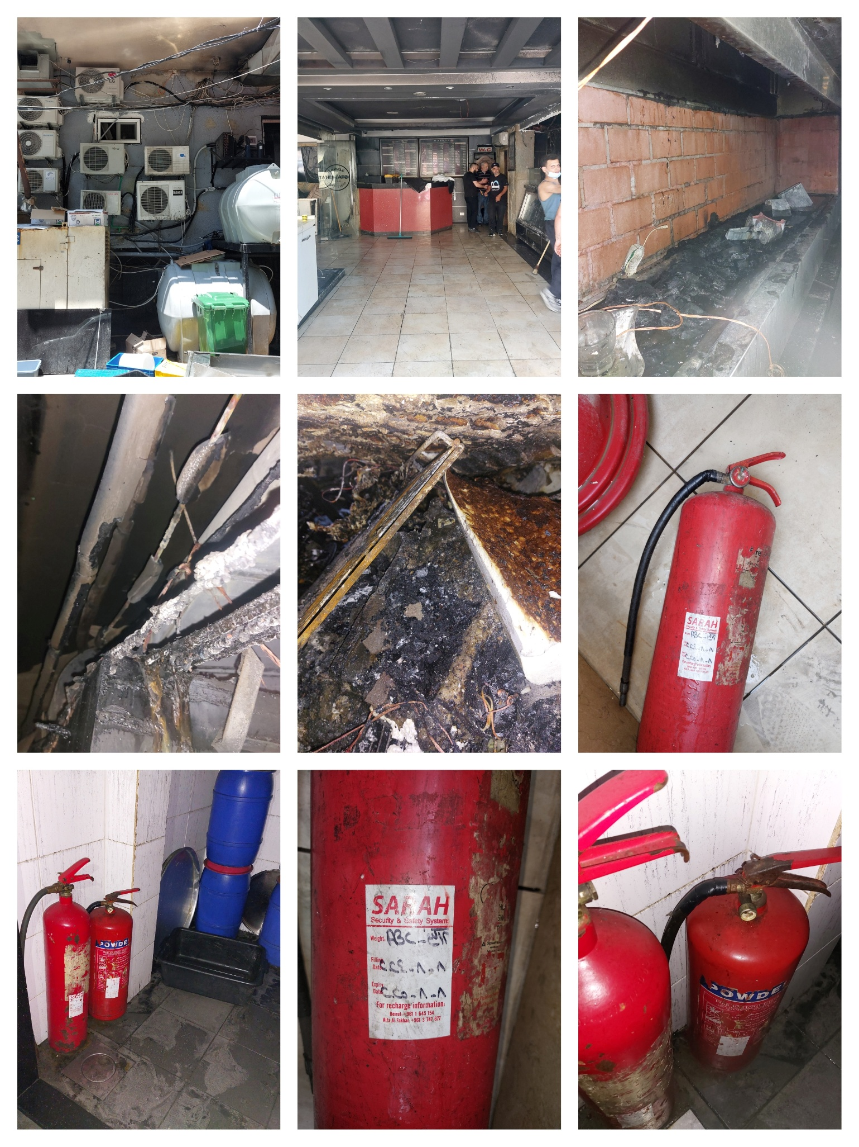
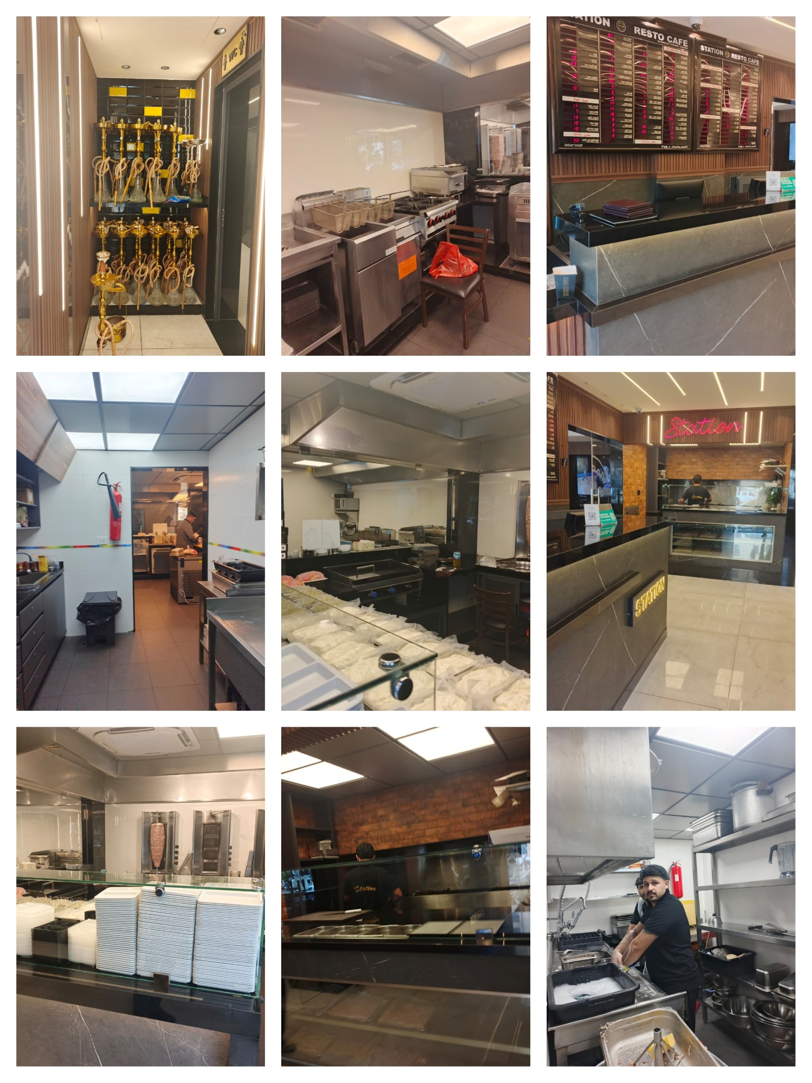
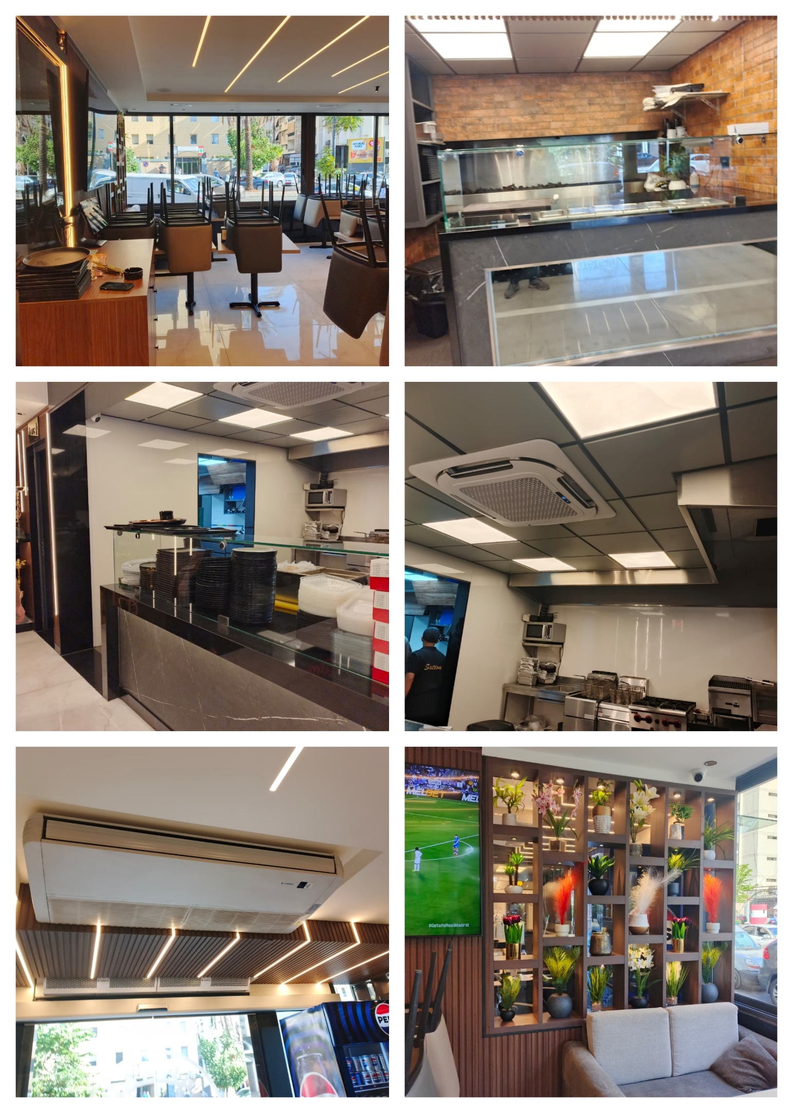
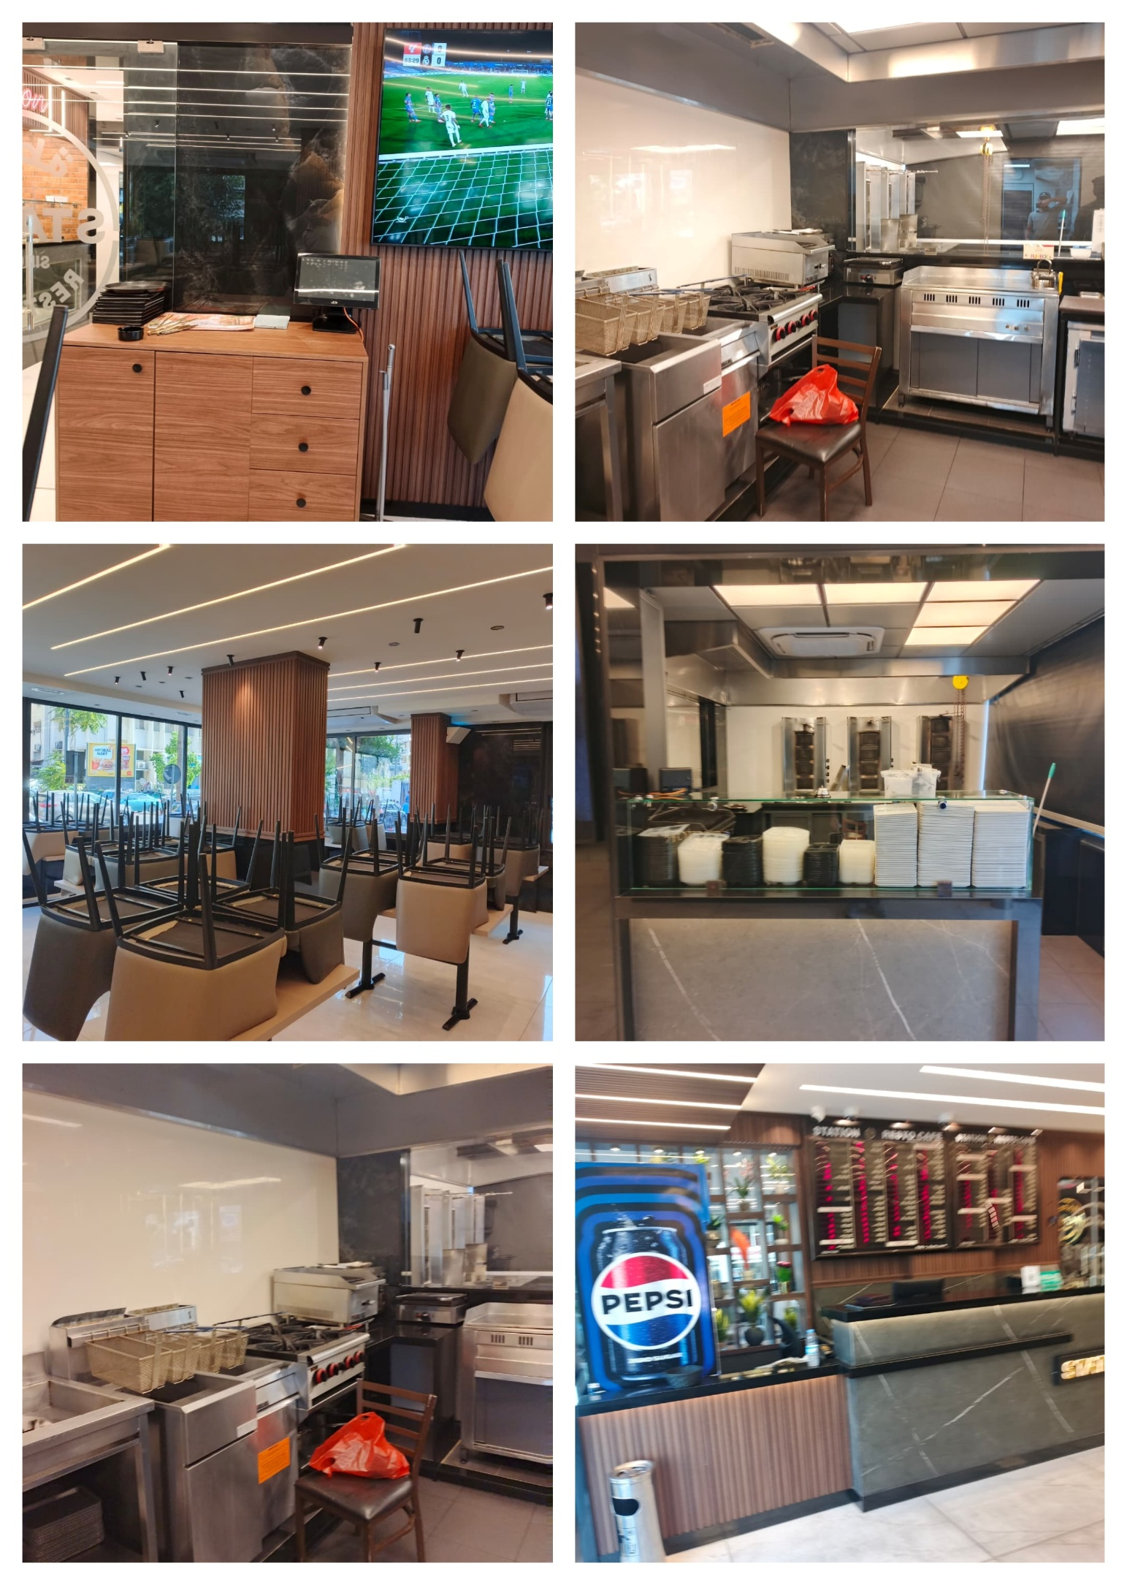

About ULA
United Loss Adjusters and Surveyors (ULA) is a leading international provider of Adjusters, Surveyors, Solicitors and Consultants, offering unrivalled technical and legal solutions with exclusive access to the London Market's leading specialists.
Founded in 2002, with strategic head offices in the Middle East and the United Kingdom, today ULA is the strategic ally of a world leading legal firm ‘Clyde & Co.’ (with offices in over 60 major countries) and the correspondent and associate for a number of global technical service providers such as ‘Charles Taylor Adjusting (CTA)’ (with offices in 140+ countries), with principals including but not limited to Insurers, Reinsurers, Brokers, P&I clubs, Ship Owners, Shipyards and Agencies.
Lines of business:
- Insurance & Re-insurance
- Claims solutions and loss adjusting across all major lines: aviation, cargo, marine, property, fine arts and special risks claims
- Cargo & Containers
- Marine & Offshore
- Global Claim Recoveries & Legal Support
Our team:
Our team of qualified professionals experienced in the fields of Marine, Insurance, Finance, Engineering and Law known and respected for their integrity and credibility. Supported by a highly mobile team strategically positioned where our services are needed, we are always available on short notice to deal promptly with your queries. ULA is independent to the core and can be trusted to express unbiased views and is not influenced by stakeholders.
ULA’s team members are recognised:
- Chartered Engineers
- Consultants
- Inspectors & Auditors
- Insurance & Re-Insurance Underwriters
- Loss & Average Adjusters
- Master Mariners & Chief Engineers
- Naval Architects, Marine & Offshore Engineers
- Solicitors
- Sworn Surveyors
ULA’s team members are also recognized members of the following international institutions:
- The Association of Average Adjusters (AAA)
- The Bar Council of England and Wales
- The Chartered Insurance Institute (CII)
- The Chartered Institute of Loss Adjusters (CILA)
- The European Federation of Loss Adjusting Experts (FUEDI)
- The Institute of Fire Engineers (IFE)
- The Institute of Marine Engineering, Science and Technology (IMarEST)
- The UK Engineering Council
- The Royal Institute of Naval Architects (RINA)
- The International Institute of Marine Surveying (IIMS)
- The Royal Institute of Chartered Surveyors (RICS)

Contact person
Petro Zaarour
Director
United Kingdom: 71-75 Shelton Street, Covent Garden | London, England - WC2H 9JQ
Middle East: Mina Tower, Ain Waraka Street | Beirut, Lebanon - WG2G+5CX

Registered name: United Loss Adjusters and Surveyors S.A.R.L

T no.: +44 (0) 20 3287 3326 (24/7) | M/WhatsApp no.: +44 (0) 7 563 498 178 | +961 (76) 610 109
Office E: petro.zaarour@unitedlossadjusters.com; claims@unitedlossadjusters.com
W: https://www.unitedlossadjusters.com/



